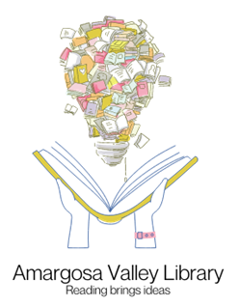

Nailed it! Contest Rules

This contest runs from May 23rd to August 6th for all ages. We ask that you re-create a viral/popular baking recipe found on the internet from the last three years. To enter send us a picture of your creation as well as the original image you were trying to match.

Other library patrons will vote on the images. There will be three winners announced on August 6th. Winners will receive a $10.00 Amazon gift card.

Send your picture to: amargosalibrary@gmail.com or libraryamargosaog@icloud.com

